**Commands used:**

1. **touch home.txt (to create the file)**

**Next, we need to change the permission set of that file**

Any User can read it.

group can read/write.

Owner can read/write/execute it. (as per the given question)

Now, we need to select the octal number for that, we are going to use the table below.

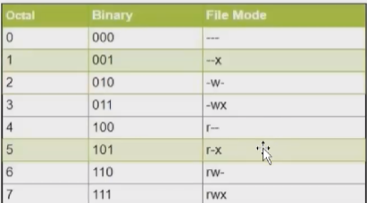

Any user can read it = r- - = 4

Group can read and write = rw- = 6

Owner can read/write/execute it = rwx = 7

User or owner (u) = 7

Group (G) = 6

Any user (o) = 4

**Command used**: chmod 764 home.txt

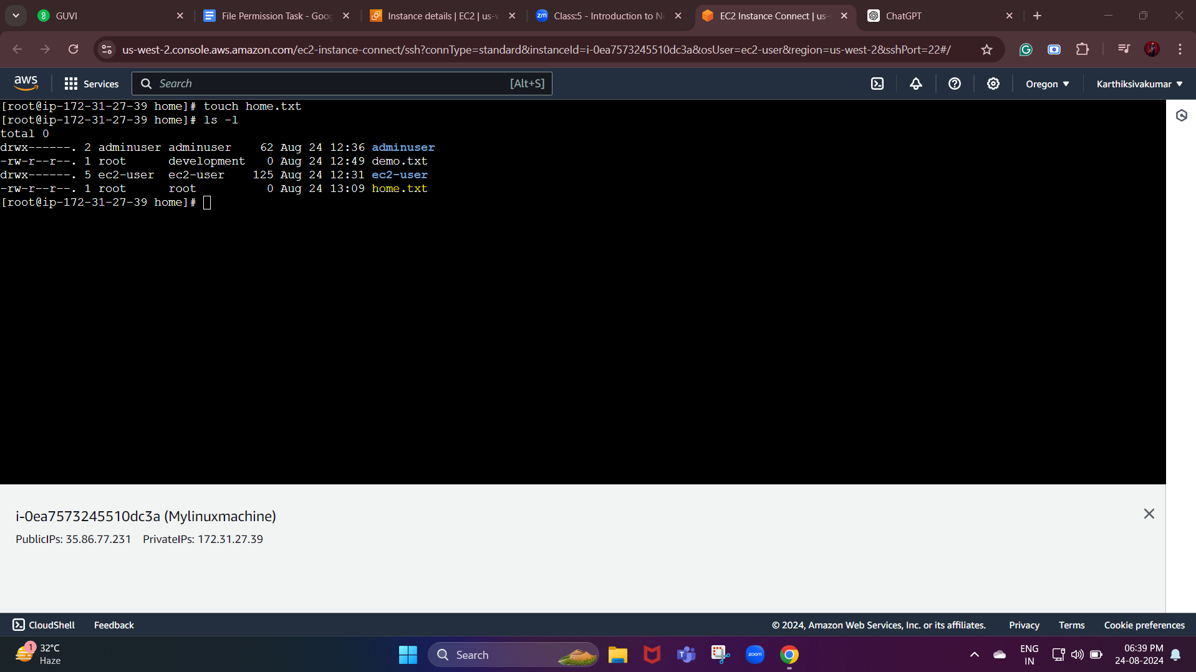

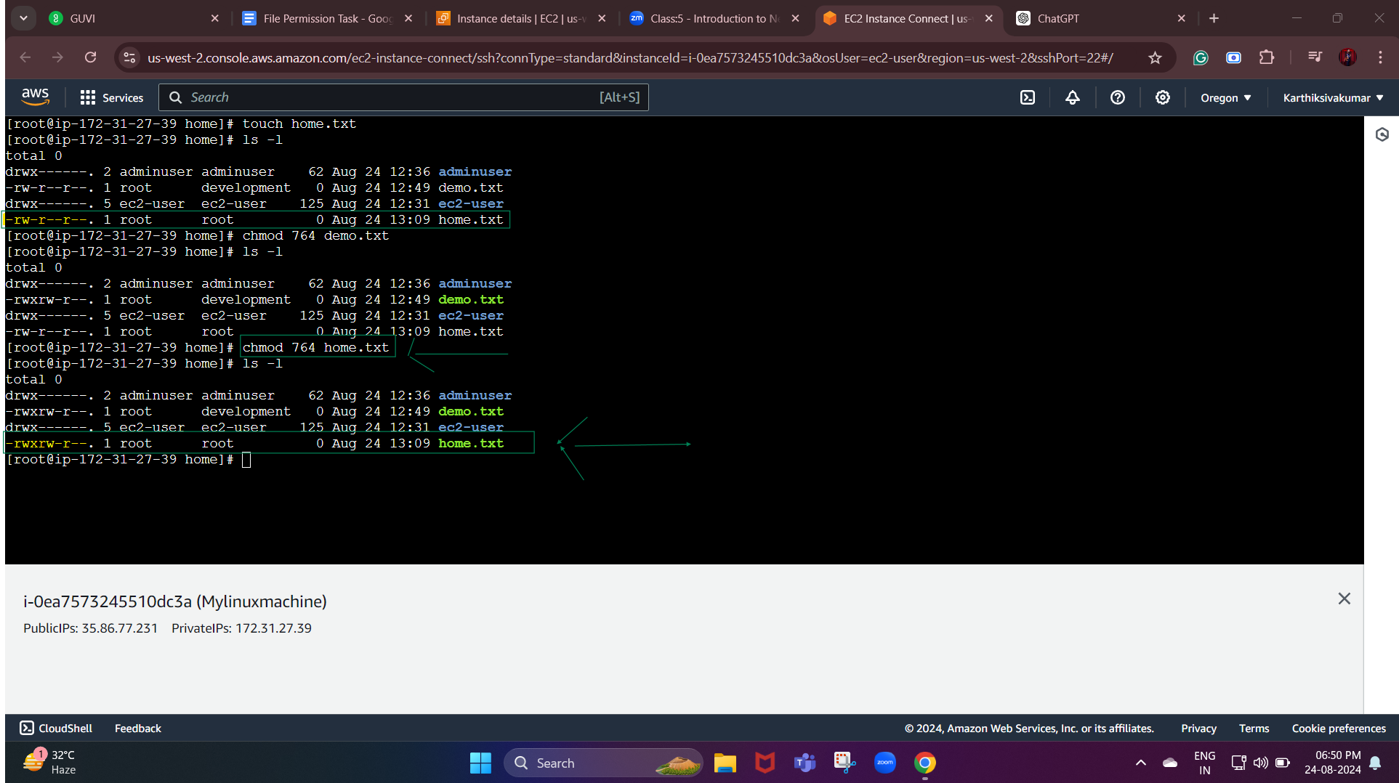

Permission:

Old format = -rw-r--r--

After giving permission = -rwxrw-r--